Name:___________________________
Bio 267
Fall 2015
Quiz 6
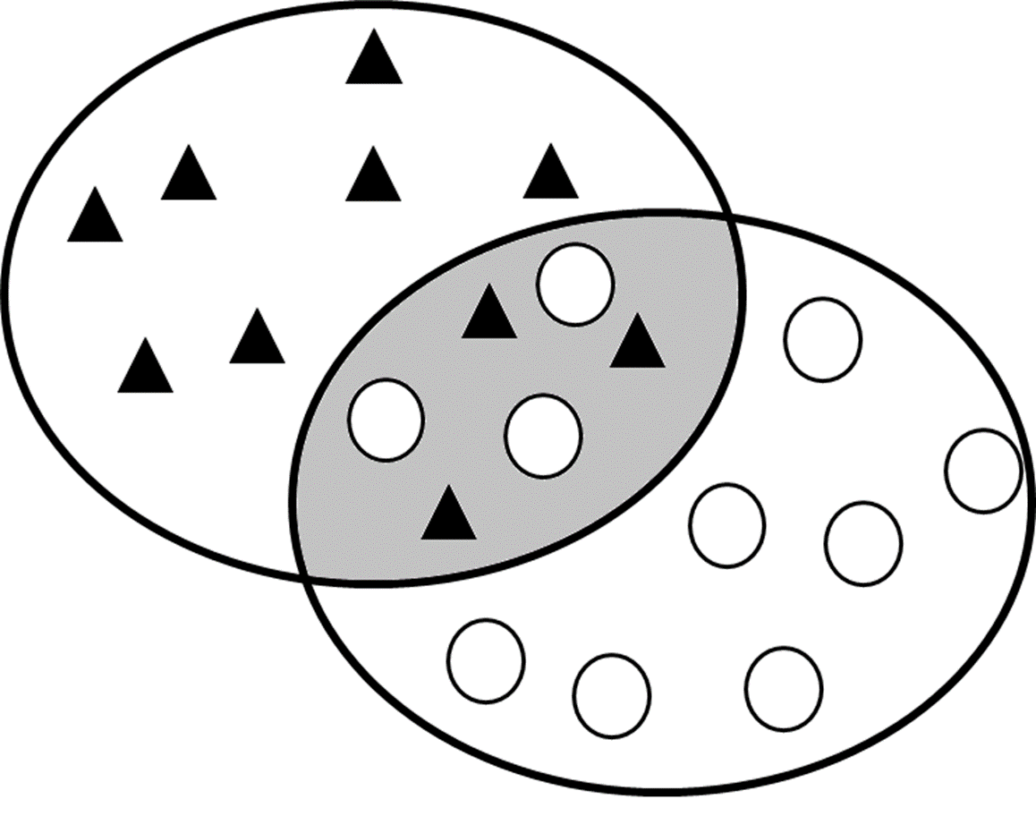
1) The figure on the right represents the geographic distribution of two closely related species (filled triangles and empty circles). The shaded area is a hybrid zone, a geographic range where the two species overlap and interbreed. Hybrid zones are often used to look for evidence of reinforcement, which occurs when natural selection favors mechanisms that reduce the formation of hybrids between two species.

Scenario 1: As mentioned in class, anubis and yellow baboons (Papio anubis and P. cyncocephalus) are two closely related species with overlapping ranges. These two species have been observed to hybridize in multiple hybrid zones in nature. Hybrid offspring are completely fertile, very healthy, and appear to suffer no fitness detriments of any kind.

Scenario 2: Drosophila pseudoobscura and D. persimilis are two closely related species of fruit flies with overlapping geographic ranges. Hybrid female offspring of D. pseudoobscura and D. persimilis are fertile, but hybrid male offspring are sterile. In nature, a hybrid zone between these two species occurs in western North America.

Scenario 3: Scientists recognize two different ‘subspecies’ of the grasshopper, Chorthippus parallelus. The two subspecies appear morphologically somewhat different, and show somewhat different behavior, which is why they are referred to as ‘subspecies’ (i.e., they are presumed to be partially isolated populations but are not quite separate species). Hybrids between these two subspecies result in sterile males but normal females. In nature, a hybrid zone between the two subspecies occurs in mountain passes of the Pyrenees mountains in southwest Europe.

Part A (2 points): Given the information above, in which of the scenarios would you expect natural selection to favor reinforcement, i.e., behavioral or morphological traits that reduce the probability of mating between the two species (or subspecies in the case of the grasshoppers)?
a) Scenario 1
b) Scenario 2
c) Scenario 3
d) Scenarios 1 and 2
e) Scenarios 1 and 3
f) Scenarios 2 and 3
g) Scenarios 1, 2 and 3

Experiments and/or observations on each of these systems has revealed evidence that allows us to hypothesize about whether or not reinforcement is acting to promote reproductive isolation. Though each group of researchers investigated the role of reinforcement in different ways, all of the results reveal something about the likely strength of natural selection acting to reduce the formation of hybrid offspring.

Scenario 1 Results: Using behavioral observations and non-invasively collected genetic data, Tung et al (2012) found that within a hybrid zone, baboons showed a slight tendency to mate assortatively (i.e., yellow baboons with yellow baboons and anubis baboons with anubis baboons). However, at the same time, anubis males and hybrid males had higher mating success than pure yellow males overall, suggesting that all females were more likely to mate with anubis and hybrid males than with yellow males.

Scenario 2 Results: Noor (1995) collected D. pseudoobscura females from populations within the hybrid zone and from populations outside of the hybrid zone. He paired both types of females with a D. persmilis male. He found that pairings that included a female from the hybrid zone were significantly less likely to mate than pairs that included a female from a population outside of the hybrid zone.

Scenario 3 Results: Ritchie et al. (1992) collected females and males from within the hybrid zone, and females and males from outside the hybrid zone. They created four experimental groups: (i) hybrid-zone females paired with hybrid-zone males with no mate choice (the mating partner was randomly assigned by the researcher), (ii) hybrid-zone females with hybrid-zone males with mate choice (they allowed females to choose their mates), (iii) females and males from a population outside the hybrid zone with no mate choice, and (iv) females and males from a population outside the hybrid zone with mate choice. This experimental design is depicted in the table below:

 | Mating partner assigned by researcher | Mate choice allowed by grasshoppers
Females collected from hybrid zone | OFFSPRING A | OFFSPRING B
Females collected outside of hybrid zone | OFFSPRING C | OFFSPRING D

Ritchie et al. found that the difference in fitness between Offspring A and Offspring B was the same as the difference in fitness between Offspring C and Offspring D; female mate choice did not improve fitness within the hybrid zone any more than it did outside the hybrid zone.

Part B (3 points):
Order the scenarios above from strongest support for reinforcement to weakest support for the hypothesis that reinforcement has occurred or is occurring in these species:

Strongest Support:_____Scenario 2_______________________________

Intermediate Support:_____Scenario 1_______________________________

Weakest Support: _______Scenario 3________________________________
2) Boughman’s (2001) work on sexual selection and speciation in sticklebacks was discussed in your reading and in this week’s lecture. Sticklebacks in Canadian lakes occur in different habitats that have no barriers between them (they can easily swim between them if they want to). , One habitat is shallow waters; here you find the limnetic form of stickleback, where males develop areas of red coloration. The other habitat is deeper waters; here you find the benthic form of stickleback where males tend to be black. Females see red more easily (they have a lower ‘detection threshold’ for red) in limnetic (shallow) habitats. In limnetic habitats where red is more visible, (i) females have a stronger preference for red, and (ii) males have a larger red area. Boughman collected fish from both limnetic and benthic habitats (and some in-between habitats) and brought them to her laboratory. She selected different combinations of one female and one male and put them in the same tank. She found that when the male and female were drawn from populations that were very different in either color or female preference, the fish were unlikely to mate.

Part A (2 point): Would you describe these two forms of sticklebacks (limnetic and benthic) as two different species? Why or why not? (Note: there is no one correct answer here; your answer will be judged on the soundness of your justification.)

Part B (2 points): Let’s assume that at some point in the future, these two forms of fish are completely reproductively isolated in nature and the two forms of fish will not mate even in a laboratory setting; i.e., they become separated by prezygotic isolation and are considered separate species by everyone. However, if you harvest eggs from one form and sperm from another, you can artificially produce a viable hybrid offspring that is able to mate with either parent form or with other hybrids and has no measurable fitness defects.

Given what you know about the real-life, current biology and behavior of these two forms of fish which of the following processes or forces could reasonably be implicated in the formation of these two imaginary future species?
a) allopatric speciation
b) peripatric speciation
c) sympatric speciation
d) natural selection
e) sexual selection
f) a and d
g) b and d
h ) c and d
i) a and e
j) b and e
k) c and e

3. (3 points) Hendry et al. (2006) demonstrated that a single population of the medium ground finch, Geospiza fortis, on Santa Cruz Island in the Galapagos exhibits a strongly bimodal distribution in beak size. That is, some individuals have large beaks (large beak morphs) and some have small beaks (small beak morphs), with almost no individuals having an intermediate sized beak. This distribution has probably been generated by a bimodal distribution of food resources (some very large seeds and some very small seeds, with few or no intermediate-sized seeds): birds with large beaks specialize on large, hard seeds, and birds with small beak specialize on smaller seeds. Interestingly, Huber and Podos (2006) showed that beak morphology has an effect on male song: large beak males sing lower frequency songs than small beak males. Huber et al. (2007) then found that females prefer to mate with males that have beak sizes similar to their own (small beak females prefer small beak males, and large beak females prefer large beak males). Huber et al. (2007) also documented that gene flow between these the two morphs is relatively low, suggesting the possibility of population divergence and incipient speciation. Which of the following statement(s) best describe(s) the likely mechanism(s) responsible for this divergence between morphs and possible incipient speciation? Assume that all traits (beak size & female preference) are heritable. Circle one answer.

a. Natural selection promotes divergence between morphs.

b. Natural selection hinders divergence between morphs.

c. Natural selection plays no apparent role in divergence between morphs based on the information provided here.

d. Sexual selection promotes divergence between morphs.

e. Sexual selection hinders divergence between morphs.

f. Sexual selection plays no apparent role in divergence between morphs based on the information provided here.

g. a,d
h. b,d
i. c,d
j. a,e
k. a,f
l. c,f

4. (3 points) Martin and Hosken (2000) were interested in the role of sexual conflict (specifically over the optimal number of mates) in driving reproductive isolation. Martin and Hosken set up three types of laboratory populations of the dung fly Sepsis cynipsea. ‘No conflict’ populations housed single females with single males, i.e., they were monogamous. ‘Low conflict’ populations housed 25 females with 25 males. ‘High conflict’ populations house 250 females with 250 males. (Note: to answer this question you don’t need to know why sexual conflict was greater in the larger populations, just that it was so). Importantly, flies in the conflict situations tend to mate more frequently but the females lay fewer eggs, possibly because they are often fending off amorous males and so have less time for egg laying.
After 35 generations under these mating regimes, females were tested for their willingness to mate, both (i) ‘within populations,’ i.e., with males from their own population, and (ii) ‘between populations,’ i.e., with males from another population of the same type (i.e., they tested monogamous females with males from other monogamous populations, low conflict females with males from other low conflict populations, and high conflict females with males from other high conflict populations). Female willingness to mate was measured by both the number of copulations observed and the number of females that resisted mating (i.e., attempted to shake off a male copulation attempt).
Females from the conflict treatments were less willing to mate overall than monogamous females, and they were less willing to mate with males from a different population than they were with males from their own population. Females in the high conflict treatment evolved greater discrimination against males from other populations than females in the low conflict condition did. These results are shown in the figures below:

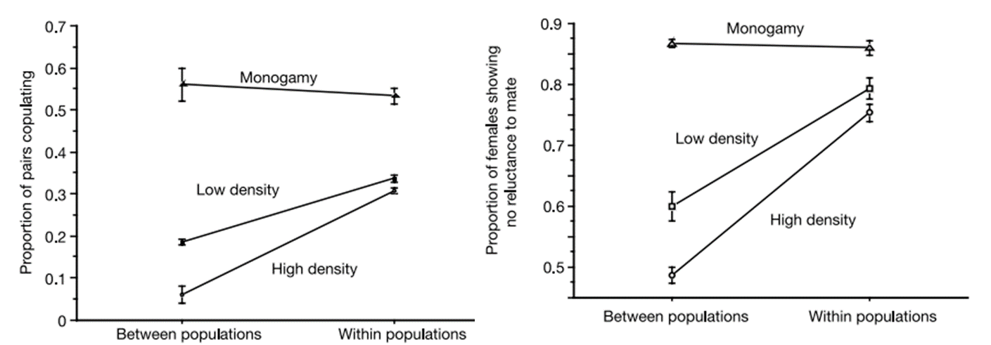
Given the experimental set up and results described, which of the following conclusions are supported?

a) Monogamous female dung flies are at an overall reproductive disadvantage compared to females with the opportunity to choose from multiple mates

b) Sexual conflict drove the evolution of reproductive isolation faster than female choice did.

c) Behavioral reproductive isolation evolved more quickly in populations experiencing sexual conflict than in populations experiencing no sexual conflict.

d) all of the above

